AML-GroupProject-2023-Group-16

General Idea:
Map a mathematical function to its plot by using an neural network.
We train our network by letting it run through a whole database of plots of mathematical funtions like sin(x), e^x , tan(x), x^2, …. to learn our network in recognizing the basic functions. There we can estimate the likelihood of random more complex functions like e^sin(x) and break it down to its characteristic componets of basic functions.
It would be really interesting to see the performance of such a neural network with complex functions. So the goal would be to put in a plot of a random function and to find out how likely it is a „cosinus“, or a „polynomial“ , … in percent.
There is a lot of room for experimentation to tweak the performance and compare it, and you can easily make the database bigger or more complex ( e.g. by adding x^2 * sin(x) , x* e^sin(x) and so on). We know that it is not possible to find out the exact solution, but to see of what basic components a random function plot exists would be very helpfull in the real world, to maybe find out typs of solutions for a problem to break down a very komplex function into an easier one.

Database of mathematical functions

Neural Network
Database of plots of these functions
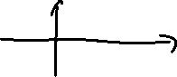

sin(x)

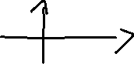

x^2

e^x

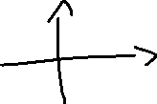

Goal:
Have a plot of a random function which basic components you want to find out

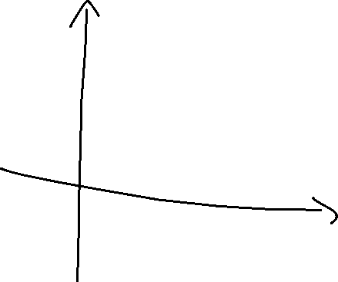
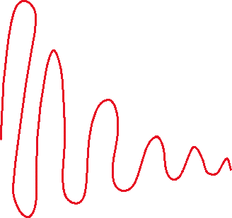

Neural Network tells you it is x.xx % a exponential function and y.yy% a sinus function, etc.

